CAPSTONE PROJECT:END TO END DATA SCIENCE PROJECT

NAME | PARTHASARATHI
COURSE | DA-DS
BATCH | MAY
PROJECT | DS-CAPSTONE

TABLE OF CONTENT:

S.NO | CONTENTS
1. | Project Overview
2. | Objective of the Project
3. | Web Scraping
4. | Data Understanding and Cleaning
5. | EDA
6. | SQL Connect
7. | Unsupervised Learning
8. | Supervised Learning
9. | Hyperparameter Tuning
10. | Save the best model
11. | New Data Prediction
12. | Insight and Recommendation
13. | Conclusion

1. | Project Overview

- As part of a growing e-commerce company, you have been assigned the responsibility of analyzing product-related data. The primary goal is to identify customer preferences, understand market trends, and provide data-driven recommendations that will improve product offerings, pricing strategies, and marketing campaigns.

- This project will integrate data collection, exploratory data analysis (EDA), visualization, and machine learning techniques to uncover patterns that can directly influence business decisions.

2. | Objective of the Project

The primary objectives of this project are:
- To collect raw mobile phone data from online sources using web scraping techniques.
- To Preprocess and clean the dataset's for consistency and usability.
- To perform exploratory data analysis (EDA) to understand patterns and trends.
- To build and evaluate machine learning models for prediction and classification.
- To extract actionable insights that help both consumers and businesses.

3. | Web Scraping

3.1 What is Web Scraping?
Web Scraping is the process of automatically extracting data from websites using software tools or scripts. Instead of manually copying and pasting information, web scraping programs (like Python scripts using Selenium or BeautifulSoup) can collect large volumes of structured data efficiently. The data may include product details, prices, reviews, news articles, or any publicly available information present on web pages.

3.2 Why do we use Web Scraping?
We use web scraping because most valuable business data is available online, but not in a ready-to-use format. For example, e-commerce sites such as Flipkart and Amazon list thousands of products with specifications, prices, and reviews. Manually collecting this information is time-consuming and prone to errors. Web scraping solves this problem by:

- Automating Data Collection → Saves time and effort.

- Market Research → Helps track competitor prices, trends, and customer preferences.

- Building Datasets → Provides raw data for machine learning and data analysis.

- Business Insights → Assists companies in improving products, pricing, and marketing strategies.
In this project, web scraping is used to collect mobile phone data from Flipkart, which will later be analyzed to understand customer preferences and market trends.

3.3. Tools and Libraries Used
Selenium → Automates the web browser and loads dynamic content.
BeautifulSoup → Parses the HTML structure to extract specific elements.
Pandas → Stores and processes scraped data in a structured format.
time → Adds delays to ensure pages are fully loaded.
webdriver_manager → Automatically installs and manages the Chrome driver.

3.4. Methodology

Driver Setup:
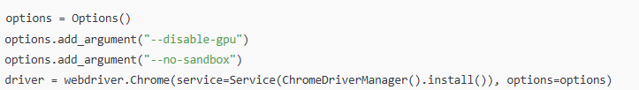

Pagination Handling:

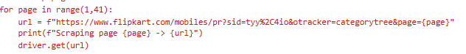

Waiting for Page Elements:

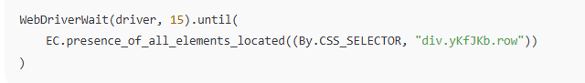

Extracting Product Information:

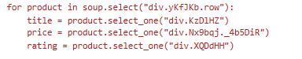
Extracting Specifications:
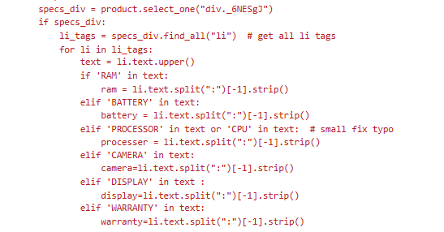

Storing Data:

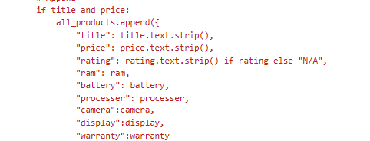

Save into CSV File Format:

4. | Data Understanding and Cleaning

- Data Understanding:
The dataset collected from Flipkart contains the following mobile phone attributes:
- Title
- Price
- Rating
- Ram
- Battery
- Processer
- Camera
- Display warranty
Columns - 9 , Rows - 956
Following the data collection phase, a series of data cleaning processes were carried out to ensure consistency, accuracy, and usability of the dataset for further analysis.

- Data Cleaning:
4.2 Rename the columns

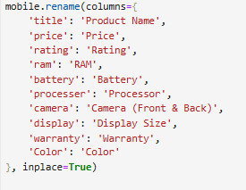

4.3 Extract the need values:
- The raw title field contained multiple attributes combined into a single string, such as mobile variant, colour, and storage capacity. For example:REDMI Note 14 SE 5G (Mystique White, 128 GB).

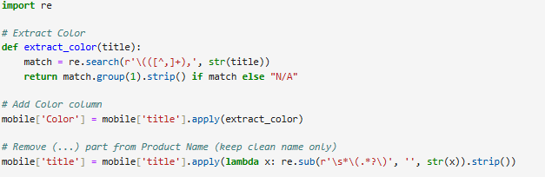

- Brand Extraction → From Product Name, the first word was taken to create a new Brand column. Ex REDMI Note 14 SE 5G

- Processor Brand Extraction → From Processor, the first word was taken to create a new Processor_Brand column. Ex Dimensity 7025 Ultra Processor

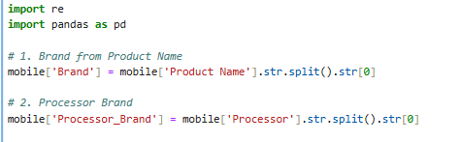

- Splitting RAM and ROM from RAM Column
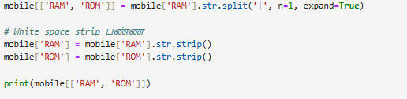
- The Camera (Front & Back) column in the raw dataset contains both back and front camera specifications combined in a single string, separated by a | symbol. For example:"64MP + 8MP | 16MP"

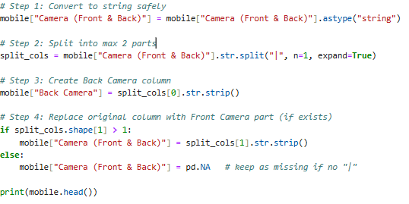

4.4 Fill Missing Ratings

- Blank values in the Rating and display size column were replaced with 0.

- For columns Front Camera, Warranty, and Display Type, missing values were filled with the placeholder “Not Mentioned” to indicate absence of information while keeping the dataset consistent.

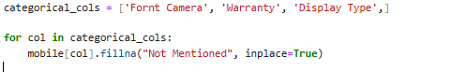

4.5 Removing Special Characters and Unwanted Strings:

- Price Cleaning :Removed the rupee symbol (₹) and commas from the Price column to retain only numeric values.

- RAM/ROM Cleaning :Removed string values such as “GB RAM” and “GB ROM”, keeping only numeric values.

- Battery Cleaning :Removed “mAh Battery ” text from the Battery column to retain numeric capacity.

- Display Cleaning → Removed “inch” and brackets from the Display Size column, keeping only numeric screen size.
4.6 Drop the unwanted columns and rows
- RAM in MB → Columns containing RAM values in MB were dropped to maintain consistency, as the analysis uses GB as the standard unit.

- Product Name → Dropped after extracting key features (Brand, Color, RAM, ROM, etc.) to avoid redundancy.

- Brand “I” → Dropped because it contains mostly missing values and provides no meaningful information for analysis.

After completing all cleaning and transformation steps, the dataset is now structured, consistent, and ready for exploratory data analysis and machine learning tasks.
AFTER CLEAN THE DATA :
- Price
- Rating
- RAM
- Battery
- Processor
- Fornt Camera
- Display Size
- Warranty
- Color
- Brand
- Processor_Brand
- ROM
- Back Camera
- Display Type
COLUMNS - 14 , ROWS -851.
5. | EDA

After cleaning, EDA was performed to identify patterns, trends, and relationships in the mobile phone dataset. Key insights on brand popularity, pricing, specifications, and customer preferences were derived using statistical measures and visualizations like histograms, bar charts, and scatter plots.

- Heatmap for Numerical Columns:

A correlation heatmap was plotted for all numerical columns such as Price, Rating, RAM, Battery, and Display Size to visualize the relationships between features.

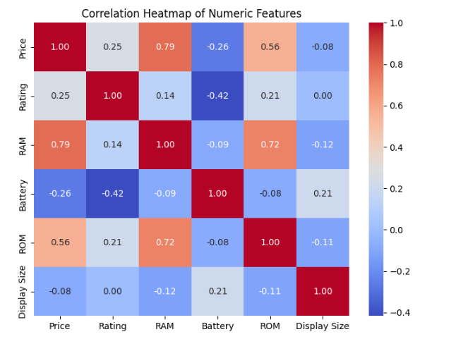

- Brand-wise Product Count:

The number of products available for each brand was calculated to understand brand distribution in the dataset. This helps identify the most represented brands and analyze market share.
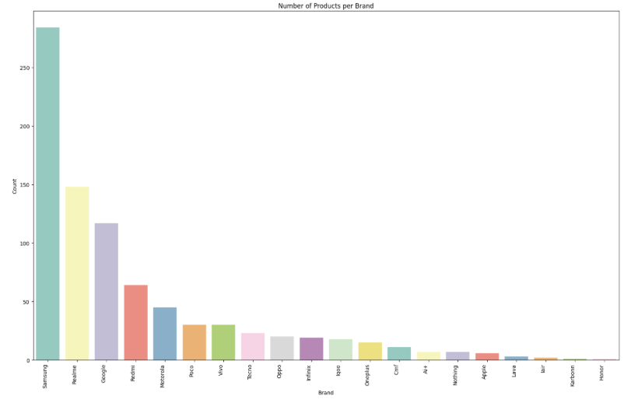

- Price Distribution:
A price distribution analysis was performed to understand how mobile phone prices are spread across the dataset. Visualizing the distribution helps identify common price ranges, outliers, and the overall affordability spectrum of the products.
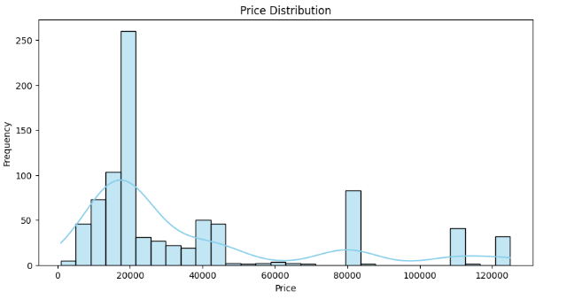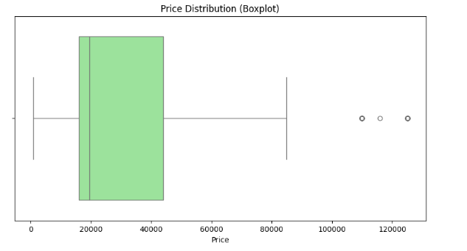
- Brand Rating:
The average rating of products for each brand was calculated and visualized to understand customer satisfaction across different brands. This helps identify which brands are performing better in terms of user reviews and perceived quality.

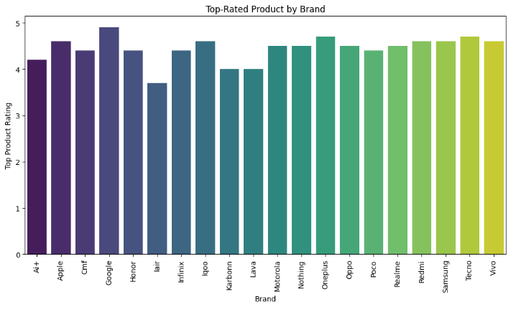

6. | SQL Connect
After completing data cleaning and transformation, the refined dataset is stored in a relational database using libraries such as SQLAlchemy. Relational databases organize data into structured tables with defined relationships, making it easier to query, update, and manage large datasets efficiently.
Why Use a Relational Database:
Structured Storage: Data is organized into tables with columns and rows, ensuring consistency.
Efficient Queries: SQL allows filtering, aggregation, and joining multiple tables quickly.
Data Integrity: Constraints (like primary keys) ensure uniqueness and prevent invalid data.
Scalability: Supports handling large datasets beyond what a simple CSV file can manage.
Re-usability: Once stored, the cleaned data can be accessed for future analysis, reporting, or machine learning projects without repeating the cleaning process.
Benefits:
Streamlines data management for multiple projects.
Enables efficient sharing and collaboration across teams.
Makes integration with analytics tools or dashboards easier.

- PUSH CLEAD DATA INTO SQL:

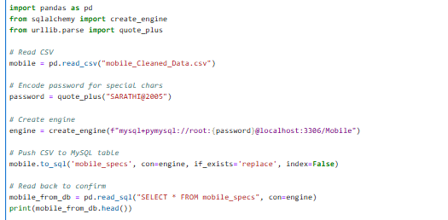
- LOADING DATA BACK FROM SQL INTO PYTHON:

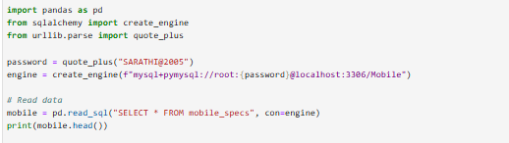

7. | Unsupervised Learning
Unsupervised learning is a type of machine learning where the model is trained on unlabeled data, meaning the output or target variable is not known. The algorithm attempts to find patterns, structures, or groups within the data without any explicit guidance.
Why it is used:
To discover hidden patterns or natural groups in data.
To segment customers or products (e.g., budget, mid-range, premium phones).
To reduce dimensions or extract important features for further analysis.
Common techniques:
Clustering (K-Means, Hierarchical)
Dimensionality Reduction (PCA, t-SNE)
Benefits:
Helps in market segmentation, recommendation systems, and trend analysis.
Does not require labeled data, making it useful for large raw datasets.
1.TWO UNSUPERVISED MODEL.
· KMeans Clustering → "KMeans is a partition-based clustering algorithm that groups data into k clusters based on feature similarity."
· Hierarchical Clustering → "Hierarchical clustering builds a tree-like structure of nested clusters by successively merging or splitting groups based on distance."
I developed two unsupervised models, identified the best-performing one using evaluation metrics, and further tuned it to achieve optimal performance.

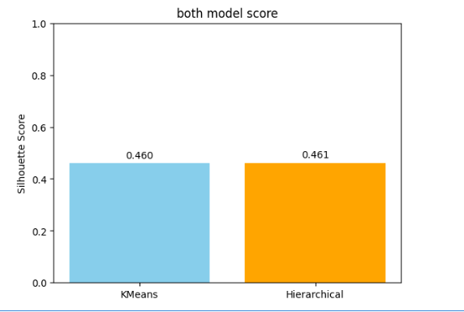

Silhouette Score: Measures how well each data point fits within its cluster compared to other clusters.
Range: -1 to 1
Close to 1 → Excellent clustering (points are well matched to their cluster and far from others).
Close to 0 → Overlapping clusters.
Negative → Misclassified points.

I chose Hierarchical Clustering because it showed a slight improvement in performance compared to KMeans.
Tuning Hierarchical Clustering:

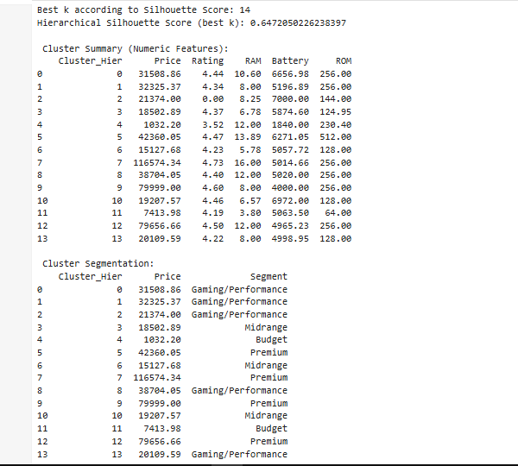

· Best K = 14
· Silhouette Score = 0.647 → pretty good. Indicates your clusters are fairly well separated.
Cluster 4 (Budget) → Price ≈ 1,032 , RAM = 12 GB (cheap entry-level devices).
Cluster 11 (Budget) → Price ≈ 7,400, RAM 3.8 GB → Low-end budget phones.
Cluster 3, 6, 10 (Midrange) → Price ≈ 15K–20K range, RAM 6–8 GB →
Cluster 0, 1, 2, 8, 13 (Gaming/Performance) → Price 20K–32K range, RAM 8–12 GB, Battery 5,000–7,000 → performance/gaming
Cluster 5, 7, 9, 12 (Premium) → Price 42K–1.1L, RAM 12–16 GB, Rating > 4.5 → Premium / flagship models.
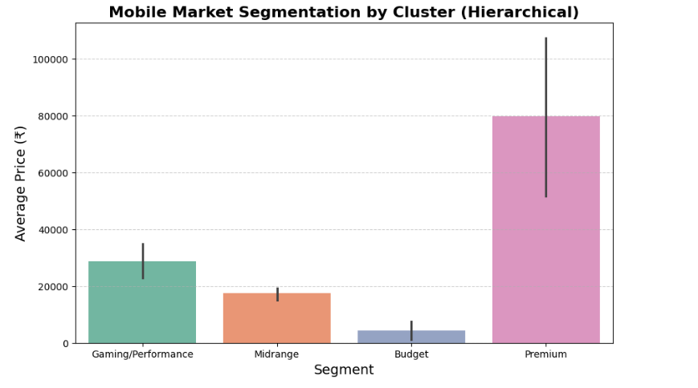

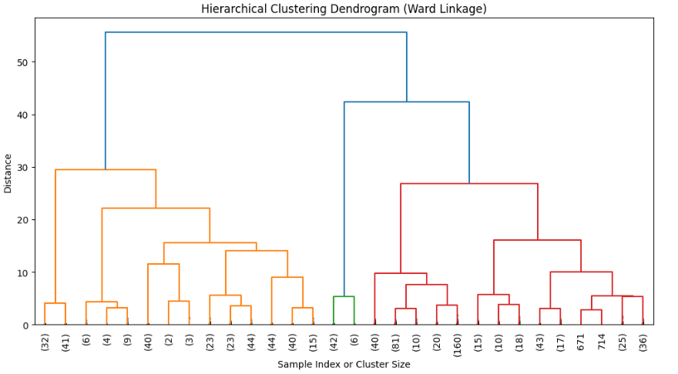
8. | Supervised Learning

Supervised Learning is a type of machine learning where the model is trained on a dataset that has input features (X) and known output labels (Y). The goal of the model is to learn the relationship between X and Y so it can predict Y for new, unseen data.
In this project, I implemented a Supervised Learning – Classification approach to predict the brand of a mobile phone based on various features such as Price, Rating, Processor, RAM, ROM, Display Size, and other relevant specifications. The model learns patterns from the labeled dataset and accurately classifies mobile phones into their respective brands.

Workflow:

- Data Collection
- Data Preprocessing
- Feature Selection
- Train-Test Split
- Model Selection & Training
- Model Evaluation
- Hyperparameter Tuning
- Prediction

- Encode the Columns :

Converted categorical features (like Processor, Brand, etc.) into numerical values using encoding techniques such as Label Encoding or One-Hot Encoding to make them compatible with machine learning algorithms.

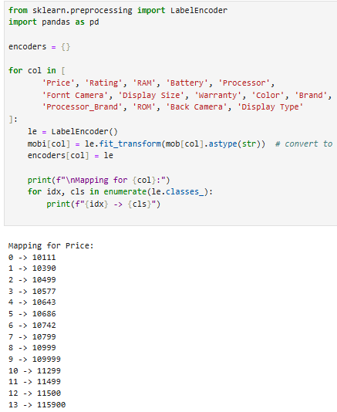
- Heatmap for all columns :

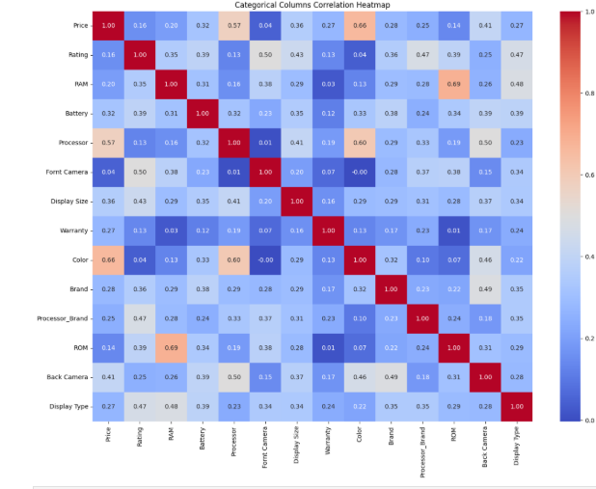

- Split the Features

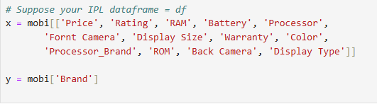

4.Filtering Rare Classes in Target Variable
This code removes target classes in y that appear less than 2 times and also removes the corresponding rows in x to keep the data aligned.
It’s basically filtering out very rare categories so the model doesn’t get confused.
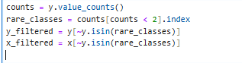

- StandardScaler

Scales numeric features so that each has mean 0 and standard deviation 1, helping models handle features with different ranges effectively.

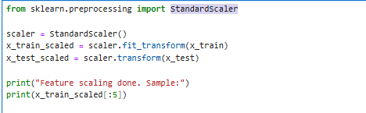

- StratifiedKFold

A cross-validation technique that splits data into folds while preserving the percentage of samples for each class in every fold. This ensures that each fold is a good representative of the overall class distribution, which is especially useful for imbalanced datasets.
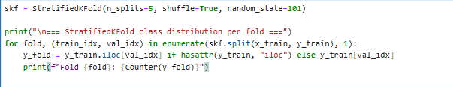

6.Classification Model
Logistic Regression – A supervised classification algorithm that predicts the probability of a categorical outcome using a logistic (sigmoid) function. Good for binary or multi-class classification.
Support Vector Machine (SVM) – Finds the best boundary (hyperplane) that separates classes in the feature space. Works well for high-dimensional data and both linear and non-linear problems (with kernels).
K-Nearest Neighbors (KNN) – A simple, instance-based algorithm that classifies a sample based on the majority class of its K nearest neighbors in the feature space.
Decision Tree – A tree-structured model that splits data into branches based on feature values to make predictions. Easy to interpret but can overfit on small datasets.
Random Forest – An ensemble of multiple decision trees that vote on the final prediction. Reduces overfitting and improves accuracy compared to a single decision tree.
XGBoost – A gradient boosting algorithm that builds trees sequentially, where each tree tries to correct the errors of the previous one. Highly efficient and accurate for structured/tabular data.

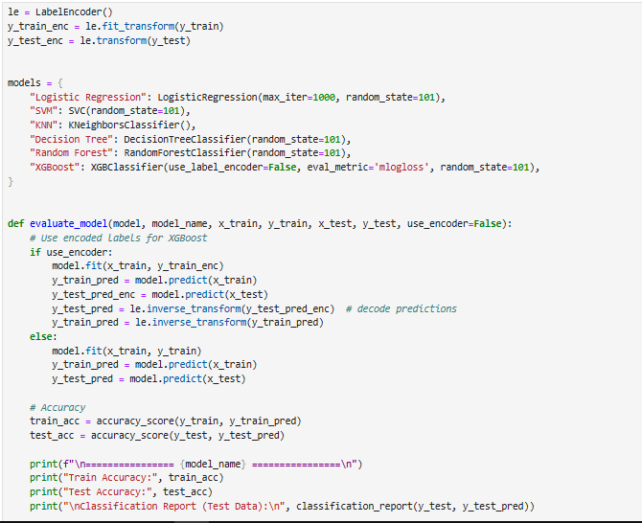

- Compare the models
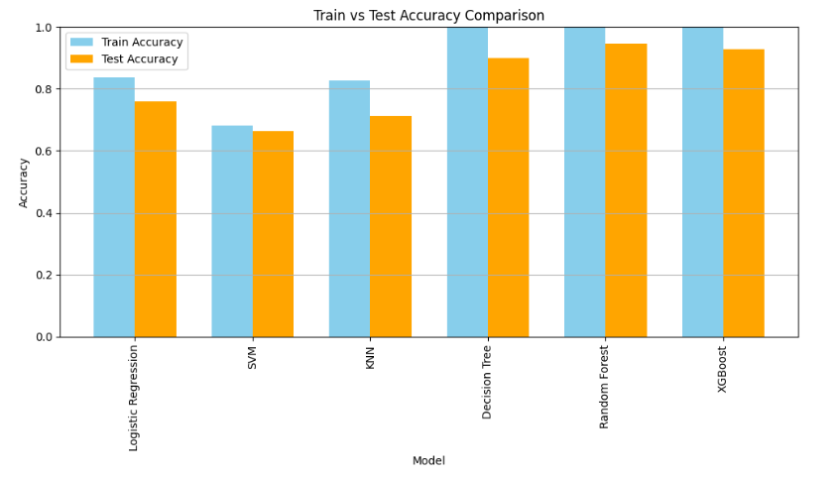
Model Train Accuracy Test Accuracy
0 Logistic Regression 0.836524 0.758824
1 SVM 0.680412 0.664706
2 KNN 0.826215 0.711765
3 Decision Tree 1.000000 0.900000
4 Random Forest 1.000000 0.947059
5 XGBoost 1.000000 0.929412
9. | Hyperparameter Tuning
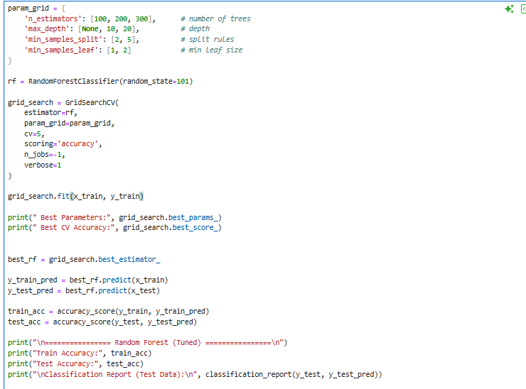
To increase model accuracy from 92% → 94%,
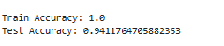
Actual and prediction 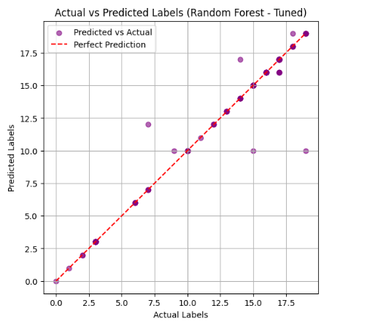
10. | Save the best model

Saving the Best Model (Random Forest) – The Random Forest model, having achieved the highest accuracy among all models, is saved using pickle for future predictions without retraining.

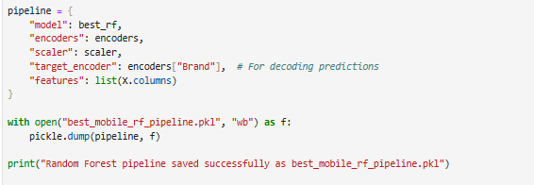

11. | New data prediction

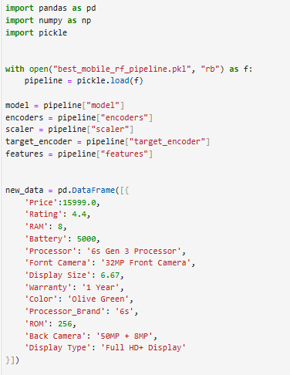
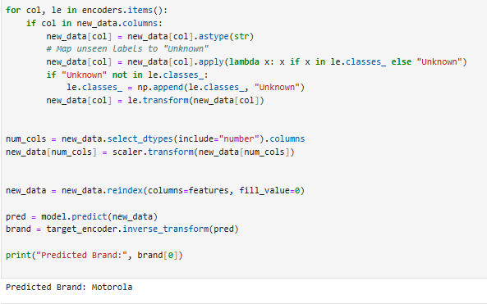
The trained Random Forest model has successfully made predictions on new data. It takes the input features, applies the learned patterns from training, and outputs the predicted target values. This allows accurate classification without retraining the model. The predictions can now be used for analysis, reporting, or decision-making in the project.
12. | Insight and Recommendation

Insights
Brand & Market Trends: Google, Realme, Samsung, and redmi are the most popular brands in the dateset. Apple and Google have fewer products but are in the premium price range and have high ratings.
Pricing Patterns: Most mobiles are priced between ₹10,000 and ₹20,000. Budget phones are less than ₹8,000 and have limited features. Premium phones are over ₹40,000 and have high ratings, showing strong brand trust.
Feature–Price Relationship: Phones with high RAM (≥8 GB), large batteries (≥5000 mAh), and top-tier processors (Snapdragon, Dimensity, Apple's A-series) are in the mid-to-premium categories.
Customer Ratings: The average rating is above 4.0, which indicates customer satisfaction. Budget phones have slightly lower satisfaction.
Unsupervised Learning (Clustering): The analysis segmented phones into four clusters: Budget (<₹8K), Midrange (₹15K–₹20K), Performance (₹20K–₹32K), and Premium (>₹40K).
Supervised Learning: The Random Forest model was the most effective, achieving 94% accuracy in predicting mobile phone brands based on specifications.

Recommendations:

For Businesses / E-commerce Platforms: Focus on stocking and promoting mid-range phones. Highlight features like battery life, camera, RAM, and processor performance in advertisements. For premium phones, emphasize ecosystem benefits and exclusive features.
For Customers: Budget buyers should check reviews for compromises on Redmi/Realme phones. Heavy users and gamers should look for phones with ≥8 GB RAM and ≥5000 mAh batteries in the ₹20K–₹30K range. Premium buyers can trust OnePlus, Apple, or Samsung for long-term performance.
For Future Work: Consider adding sentiment analysis for customer reviews, constantly update the dataset, and deploy the Random Forest model as a real-time recommendation system.
13. | Conclusion

This project successfully created a complete machine learning pipeline by:
- Scraping data from Flipkart.
- Cleaning and preparing the data.
- Using Exploratory Data Analysis (EDA) to find market trends.
- Using unsupervised learning to segment phones.
- Using supervised learning to predict phone brands, with the Random Forest model achieving high accuracy.

The key takeaway is that the Indian smartphone market is dominated by mid-range devices, while premium brands still have a loyal customer base. The insights from this project can help businesses with inventory management, pricing, and marketing, and can assist customers in making smarter purchasing decisions. The project shows how data science can be applied to real-world decision-making.

THANK YOU

